
IB End-to-End DATA ENABLEMENT
Project Test Approach

Document Overview
The objective of this document is to detail the approach to be employed in the management of the testing for the IB E2E Data Enablement Project.

In summary, the Test Approach will provide information on how testing will be approached for the project to ensure the solution has been built to specification and is fit for purpose: It will outline the following:
- Test phases in scope
- Test scope coverage
- Teams and resources involved
- Test timelines

A Test Plan document will be developed for each Test Phase detailing what will be covered and performed.
DOCUMENT CONTROL
Title | IB E2E Data Enablement Test Approach
Prepared by | Test Centre of Excellence (Global Solution Delivery)
Approved by | Alex Lutke Schipholt
Version Number | 0.5
Version Date | 28/09/22
Version Control

Date | Version No. | Author | Comment
29/08/22 | 0.1 | Rohit Ravindran | Initial Draft
16/09/22 | 0.2 | Rohit Ravindran | Incorporated review comments from Alan:  - Additions to Document Purpose  - Corrections to System Under Test and Other Systems sections  Incorporated review comments from Kishan:  - Added Related Systems in Test Environment section  - Removed additional project entry criteria, added,  - Added points on doing basic connectivity and structure related tests with the assumption that the interfacing systems (upstream/downstream) are available
22/09/22 | 0.3 | Rohit Ravindran | Incorporated review comments from Katarzyna on  - Example of previous testing phase  - Power BI Dashboards scenario  - Reliability testing  Renamed Unit Integration Test to System Unit Test as suggested by Lalit
27/09/22 | 0.4 | Rohit Ravindran | Below updates made after review by Heena and Lalit  - Split Regression Testing into System Regression (Data Hub) and BAU (in case of changes to other systems) Regression  - Added Data Migration (Historical Data Validation) Testing  - Added comment calling out the need to create a matrix for the testing focussed on other Upstream and Downstream systems and the teams responsible for doing these tests  Other Update:  Added Distributor Stock in Diagram in System Landscape Overview Section
28/09/22 | 0.5 | Heena Patel

DOCUMENT APPROVAL

Name | Position | Role | Date | Evidence
Heena Patel | IB Test CoE Programme Test Manager | A
Kishan Maisuria | Head of Testing, IB Global Solution Delivery | A
Nilesh Bhalsod | Head of IB Test CoE | A
Katarzyna Michalowska | IB Business Project Manager | A
Lalit Kapur | IB IT Project Manager | A
Alan Exell | Capgemini Project Manager | IR
Mark Gregory | Capgemini Solution Architect | IR
Nilesh Soni | Capgemini Development Lead | IR

Role to be defined per person as one of the following categories: A = Formal Approval Required, IR = Informal

1. Introduction 4
1.1 Project Background 5
1.2 Document Purpose 5
1.3 References 5
2. Project Test Scope 6
2.1 Project Testing Objectives 7
2.2 In Scope of <phase> Testing 7
2.3 Business in Scope 7
2.4 High-level Processes & Functionality in Scope 8
2.5 Out of Scope of <phase> Testing 9
3. Project Test Approach 10
3.1 Core Test Phases (In & Out of Scope) 11
3.2 Non-Core Test Phases in Scope 11
3.3 Entry and Exit Criteria 12
3.4 Standard Entry Criteria 12
3.5 Standard Exit Criteria 12
3.6 Project Entry Criteria in addition to Standard 13
3.7 Project Exit Criteria in addition to Standard 13
3.8 Project Test Environments 13
3.9 Test Data Provisioning 13
3.10 Test Deliverables 13
4. Deviations from Test Strategy 14
5. Management Processes 16
5.1 Defect Management 17
5.2 Testing Metrics & SLAs 18
5.3 Scripting 18
5.4 Reporting 18
5.5 Release Management 18
5.6 Configuration Management 18
5.7 Suspension/ Resumption Criteria 19
6. Project Test Planning 20
6.1 Test Schedule & Timeline 21
7. Project Test Resource Model 22
7.1 Resource Plan 23
7.1 Resource Plan Roles & Responsibilities 23
7.1 Staff Training Needs 25
8. RAID 26
8.1 Project Test Risks 27
8.2 Project Test Assumptions 27
8.3 Project Test Issues 28
8.4 Project Test Dependencies 28
9. Appendix 29
9.1 Eg, Test Scope and Events 30

INTRODUCTION

Project Background
Within Imperial Brands there is a need for a Data Hub to underpin the objective of providing a central data repository for managing and integrating corporate data assets.
The vision of the Data Hub is to be a global data platform to unify Demand Forecasting & Planning Data Integration activities and provide modern processing capabilities on a flexible cloud-based platform.

Document Purpose
This draft of this overarching Test Approach document is intended to allow development of the IB Data Hub Unit and System Unit Test Plan and contains the minimum information to support that aim. The expectation is that the document will be subsumed into a Programme level document in due course. This will not be formally agreed until the Programme Document is completed.
This document defines the specific testing requirements for the IB E2E Data Enablement Stream project in terms of detailed phase approach (particularly the delivery methodology), detailed scope of test scenarios, resources required and timelines. The approach inherits everything from the Master Test Strategy document and defines and justifies any and all deviations from it.
This document is to be formally reviewed and signed off by the Project Management Team to certify that it is aligned to the project requirements.

References
Background information for Testing and Project information referred to in the Test Approach (this document) can be found in the following documents:

Testing Documents | Project Documents
Master Test Strategy | A.01 Demand Planning Business Requirements Document
 | A.02 Data Hub Source-Target Mapping Document
 | A.03 Project Plan
 | D.01 IB Data Hub Solution Design Document
 | A.05 IB Data Mapping and Model Document

Please see below the structure of the Test Documents for this project:

PROJECT TEST SCOPE

Project Testing Objectives
The primary objective is to validate that Data Hub meets stated Requirements
in its role of supporting Demand Forecasting and Planning systems within the IB Supply Chain Landscape.

The Data Hub requirements encompass capturing data from Source Systems, performing transformations and provisioning data sets in the required format to Consuming Systems.

This table lists the testing goals for this Test Phase, how the objectives will be satisfied and how success will be measured.
Testing Objectives | Tested By | Measured By *
Focus on business process involving business early in quality/testing process | Attendance of Business process leads in scoping workshops | Signed-off test scope
Test scope is risk-based focusing on what is important to the business | Risk-based testing metrics used in scoping workshops | Signed-off test scope
Successfully enter Test Execution | Previous test phase exit criteria met, reviewed and formally exited.  Test entry criteria met, reviewed and formally entered  e.g. To start User Acceptance Testing the defined Exit Criteria from the previous Test Phase of End-To-End Testing should be met. | Previous test phase formally signed-off.  Test entry formally signed-off
Confirm integration points of the system are functioning as expected | Execution of E2E business processes covering integration points  - Intra system  - Inter system  - Cross functional | Test execution results and open defects in a Test Management Tool
Functional Requirements Met | Test scenarios mapped to Functional Requirements | Mapped tests successfully executed
Business Requirements Met | Test scenarios mapped to Business Requirements | Mapped tests successfully executed

In Scope of Testing
This section will document the Business Areas, High-level Processes and Functionality in the scope of testing.

Business Areas in Scope
DATA HUB is being developed as a Data Platform across global markets that delivers integration capability with Forecasting, Demand Planning and Reporting tools.
Provide a list of the functionality delivered as part of the project.

High-level Processes & Functionality in Scope
The table below contains the high-level processes considered for Testing as defined in the Process decomposition document (Risk Based Testing Template).

High-level Process | Sub-process | Number of Tests
Data Hub (Data Platform) | - Stock Keeping Unit (SKU) Level Conversion  - Sales History Aggregation  - Forecast Data Disaggregation  - Time Conversion  - Unit of Measure Conversion  - Geography Conversion
Forecasting | - Sales Demand Forecasting  - Market Size Forecasting
Demand Drivers | - Pull Demand Drivers from HIVE  - Manual Delta Loads
Store Forecast changes /Extracts | - Forecast Changes (by Planners in APO)
MDM | - Pull Master Data
KPI Reporting | 18 KPI Definitions and below Visualizations:  - Bias – Forecast Vs Actuals  - Sales Volume (Bar Chart with trendline)  - Waterfall Chart  - Heat Map  - Consolidated BOP Dashboard (Amalgamation of 17 Charts)

The below embedded workbook shows the list of scenarios in scope for validation in Data Hub, determined during RBT analysis:

Note: Some of these scenarios are initiated in Legacy (Upstream/Downstream) systems. However, the testing scope for Unit and System & Interface Testing is limited to validating the storage and processing of data in Data Hub in the format mandated for consuming systems, in line with Business Requirements

Out of Scope for Testing
This section will document the Business Areas, High-level Processes and Functionality not in the scope of testing.
At the time of writing, the following are considered out of scope of phase testing; specific inclusions and exclusions will be confirmed following the completion of the scoping workshops:

Out of Scope Item | Summary | Rationale for Exclusion
MDM System | Master Data Management System feeding into the Forecasting and Demand Planning Landscape | Testing of the MDM System and internal processes is out of scope for this Project. It is deemed that the MDM System contains all the required Master Data (conversion factors including SSKU and Product Group mapping) during the testing phases
Internal Noodle. AI processes | Forecasting system that Interfaces with Data Hub | This is the responsibility of the Team that has implemented Noodle. AI for IB
APO processes | Demand Planning system that Interfaces with Data Hub | This is the responsibility of the Team that has implemented APO for IB
Hive | Azure based Data Platform that provides Demand Driver data to Data Hub | This is the responsibility of the Team that has implemented Hive

PROJECT TEST APPROACH

Core Test Phases (In & Out of Scope)

Following the Master Test Strategy, the core test phases have been assessed for inclusion into scope and the table below details the results of the assessment:

In Scope

Core Test Phase | In Scope  (Y/N) | Responsible | Test Phase Summary/Exclusion Reason
Unit Tests (UT) | Y | Capgemini Data Hub Data Engineers | Using the Requirements and Solution Design as basis, Unit testing is performed on individual units (e.g. notebooks/runnable code performing data quality checks and transformations) of Data Hub with limited, extracted source data.  This level will also validate datasets generated in each storage layer along with Data Quality checks (Formats, Null Values, Duplicates, Completeness)
System Unit Tests (ST) | Y | Capgemini Data Hub Test Team | An extension of Unit Tests, this phase validates Data Hub Business Requirements with various units integrated to trigger specific business processes within the scope of the Data Enablement Workstream. This will involve running a master pipeline that will automatically invoke the necessary code (notebooks) and move data end-to-end, performing clean-up and transformations across the Landing-Curated -Model Layers  Interfacing systems (Upstream and Downstream Systems) and required support should be made available by IB to do basic connectivity and structure related checks.
End-to End Integration Tests (E2E) | Y | IB Testing COE | End-to-End Integration testing validates the integration of Data Hub with actual upstream and Downstream systems under real- world Demand Planning scenarios. Data movement and processing through multiple systems within the IB Supply Chain landscape is validated in this phase.  Capgemini Data Hub Test Team to support by validating results only on Data Hub while these End-To-End tests are being executed.
Non-Functional Requirements (NFR) Test | Y | Imperial Brands Testing COE | Non-functional test types in scope are as below:  - Performance Testing  - Security Testing  - Availability Testing  - Reliability Testing  - Integrity Testing
Data Migration Testing | Y |  | Tests to verify Historical Data Migration
User Acceptance Test (UAT) | Y | IB Business Users | Business processes Acceptance testing to ensure users can carry out their day-to-day activities. This also includes Testing of Reports/Dashboards used for decision making.
Operational Acceptance Test (OAT) | Y | Operations Team identified for Warranty Period | Refers to the part of Non-functional Testing that validates those appropriate processes and procedures are in place to allow the system to be used and maintained
Regression Tests (RT) | Y | Imperial Brands Testing COE | System Regression: Tests to ensure that a previously tested version of Data Hub is still working following the introduction of new functionality (CR), code or data and that the change has not had any unexpected impact on existing functionality.  BAU Regression: Changes within legacy and integration systems will also need to be regression tested.

Out Of Scope

System(s) Under Test | Test Phase(s) | Exclusion Reason
Forecasting System (Noodle.AI),  Demand Planning System (APO), Hive, MDM | All Core and Non-Core Test Phases for these Systems. | This is the responsibility of the teams that manage Noodle.AI and APO implementation for IB

Non-core Test Phases in Scope

For the IB E2E Data Enablement Stream project, in addition to the core test phases, the following test phases are to be included in the testing, due to the technical nature of the project. These are detailed below:
Core Test Phase | In Scope  (Y/N) | Responsible | Test Phase Summary/Exclusion Reason
Production Acceptance Test | Y | Support Team identified for Warranty Period | Testing key processes once the solution has been deployed into the live environment and before it is released to users

Entry and Exit Criteria
The standard testing Entry/Exit Criteria are defined in the Master Test Strategy document. They are detailed below and are to be met by the delivery of testing for this project.

Standard Entry Criteria
Standard Entry Criteria
Project Test Approach document signed-off
The previous Test Phase completion report has been sent to the Imperial Brands Test Management team and test evidence is available for review
Test resource agreed
Test scope signed-off
Test scripts reviewed and signed-off by relevant parties
Test environments commissioned, available and verified as operational
Test Data available in environment (via data migration if appropriate)
Testers have access to environment
Business Requirements and Change Requests are documented and approved
Release Plan has been defined and approved

The standard testing Entry/Exit Criteria are defined in the Master Test Strategy document. They are detailed below and are to be met by the delivery of testing for this project.

Standard Exit Criteria
Standard Exit Criteria
All tests have been executed and the results accepted by Imperial Brands
All in-scope test requirements have been tested
Test evidence is available in Imperial Brands test repository
No unresolved critical defects. All unresolved defects reviewed and agreed with the stakeholders as having a tolerable short-term impact and an acceptable resolution plan
All changed software has been tested and verified
All software interfaces and reports have been validated
Any outstanding risks have been documented
All required documentation is complete
The final Daily Test Execution Report provided to Change team to allow code to be promoted

Any specific Entry/Exit Criteria for this project or any modifications to the defined standard criteria that were determined by the Project Board are documented below and to be signed-off along with this document:

Project Entry Criteria in addition to Standard
Project Entry Criteria | Measure

Project Exit Criteria in addition to Standard

Project Exit Criteria | Measure
Not Applicable | Not Applicable

Project test environments

This section describes the various components that should be provisioned and made available for Testing

 | DEV (Unit Testing) | TEST (Unit Integrated Testing)
Azure Subscription | IHUBZ-RG-WEU-ADF-DEV-01
ADF (Data Hub - Pipelines)
ADB (Data Hub - Processing)
ADLS (Data Hub - Storage)
SQL Server (Metadata)
AWS S3 (path) related to Noodle.AI
Noodle.AI
SAP APO
HIVE
Power BI Dashboards
MDM (Kalido) | All conversion factors including SSKU, Product Group mapping, Geography and Unit of Measure must be made available as a CSV flat file in a shared location. Pipelines to pull this data.

SYSTEM LANDSCAPE OVERVIEW

<Brief description/picture of the solution and system including interfaces with other system within this project>
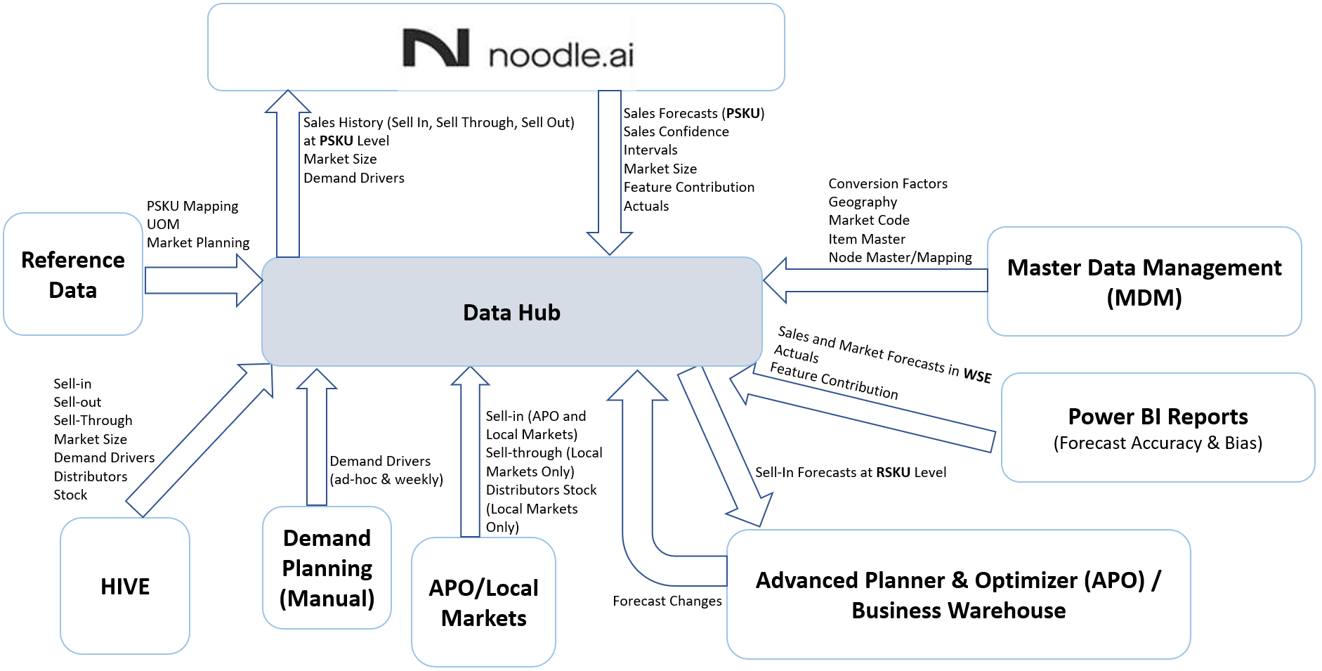

IB Supply Chain Landscape (Simplified View)

System(s) Under Test
Name | Technical Name
Data Hub | << TBD >>
Reports/Dashboards (Reporting on KPI’s in scope | << TBD>>

Other Systems
Name | Technical Name
Noodle.AI | << TBD >>
APO | << TBD >>
MDM | << TBD >>
Hive | << TBD >>

Test data provisioning

- Historoical Data from On Prem and Cloud Data Sources will be ingested into the Landing Zone as an entry point

- Master Data will be loaded into Data Hub using CSV Flat file

- Incremental data loads will be ingested into the Landing zone using Azure Data Factory Pipelines

Test deliverables

Deliverable | /
Project Test Approach | 
Test Phase Plan/s | 
Test Requirements Coverage | 
Test Cases and Scripts | 
Test Scenarios | 
Test Execution Schedule | 
Daily Execution Reports | 
Daily Defect Meetings | 
Test Phase Completion Report | 

DEVIATIONS FROM MASTER TEST STRATEGY

Deviations From Test Strategy
For the testing of this project, in addition to the excluded test phases, the following key deviations from the Master Test Strategy are noted:

Deviation | Reason for Deviation
None | None

MANAGEMENT PROCESSES

Defect Management
The defect management process is defined in the Master Test Strategy document and will be implemented for this project.
The Project will use the below Defect Workflow (showing the possible defect status transitions) configured in X-Ray Test Management Tool.
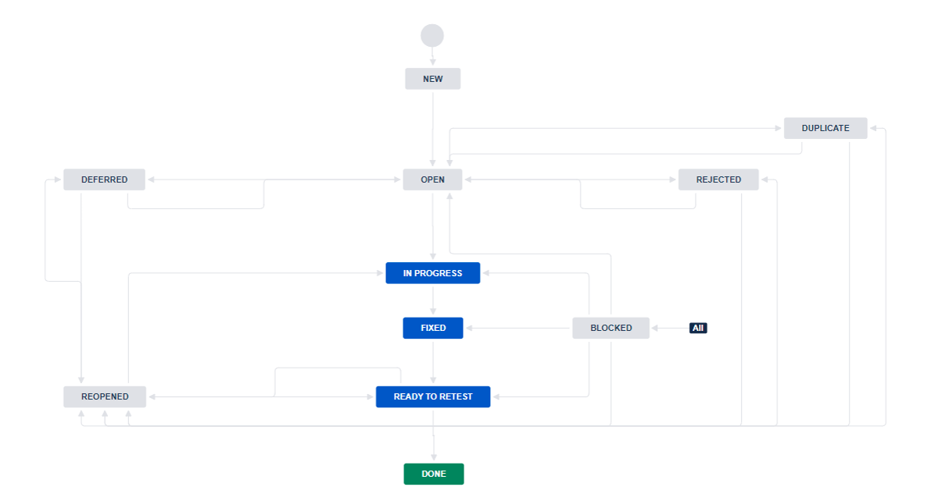

Throughout Test Execution, daily defect triage meetings will be held to evaluate each deviation from expected results, confirm if it is a flaw in the design or build, define the impact and assign the
correct resource and required timescale for resolution.

Testing Metrics & SLAs
The following KPIs are recommended to be tracked during the project:

KPI | Purpose
Test Scope Coverage | To show how many tests are required to cover the project requirements
Test Build Productivity | To show the actual effort spent on building test scripts for a project to enhance future estimating and budgeting
Entry / Exit Criteria exceptions | Show how the defined entry / Exit criteria and associated governance is adhered to for a project
Test Execution Delays | To highlight any time and associated cost impact of delaying the planned start date of testing to the project
Cost of Testing | Demonstrate how much time is spent on testing to enhance future estimating and budgeting
Defect Root Cause | Show the overall root cause of defects to drive improvement throughout the SDLC

Scripting
All scripts will be entered in XRAY, a JIRA Native Test Management Tool for consistency, traceability between requirements/tests/defects and ease of reporting. The scripting of tests will be completed as per the scripting schedule.

Reporting
<Description of the progress reporting process, when progress reports will be issued and general content included>

Report | Details
Test Preparation Report | Daily scripting progress report detailing actual vs planned and script status
Daily Execution Report | Execution progress over time  Execution progress by functional area  Execution progress against plan  Defect Status Summary
Test Phase Completion Report | Details of the testing carried out  Defect analysis and root cause analysis

Release Management
<Description of overall release management both during and after test, expectation of communication with release manager>
Release Manager to define DEV and TEST/Pre-PROD Stages in Azure DevOps.
Builds should have no work items with Active issues/bugs in order to deploy it to TEST Stage. Deployments from DEV to TEST stage would require Approvals from Release Manager. Any subsequent Pull Requests would require Approval from Development and Testing Leads. Pull requests and related deployment artifacts to be related to bug fix or CR
In JIRA for traceability and audit trail.

Configuration Management
<Description of overall configuration management and processes, who will this be managed by and with which too

Suspension/ Resumption Criteria
If during <<test phase>>, defects are found which severely impact testing progress (No further testing will add value or be possible), the programme test manager may choose to suspend testing. The criteria that justify testing suspension are:
- Hardware/ software is not available at the times indicated in the schedule
- Source code contains critical defects; further testing is impossible or of little value
- Assigned test resources are not available when needed by the test manager
- Insufficient functionality has been delivered to add value to testing the available functionality

Resumption will only occur when the problem(s) that caused the suspension has been resolved. When a critical defect(s) is the cause of the suspension, the test team must verify the ‘fix’ before testing can be resumed.

PROJECT TEST PLANNING

Test Schedule & Timeline
<Overall test schedule for the project against the main project timeline. Insert a timeline showing overall delivery and indicate when key test phases will occur>

Note: Below timelines are indicative at this point of time and is subject to further updates. Co-ordination and alignment will be needed with Noodle.AI team and the team that manages APO to do basic connectivity and structure checks during the System Unit Testing phase. Same is the case with the End-to-End Integration testing phase.

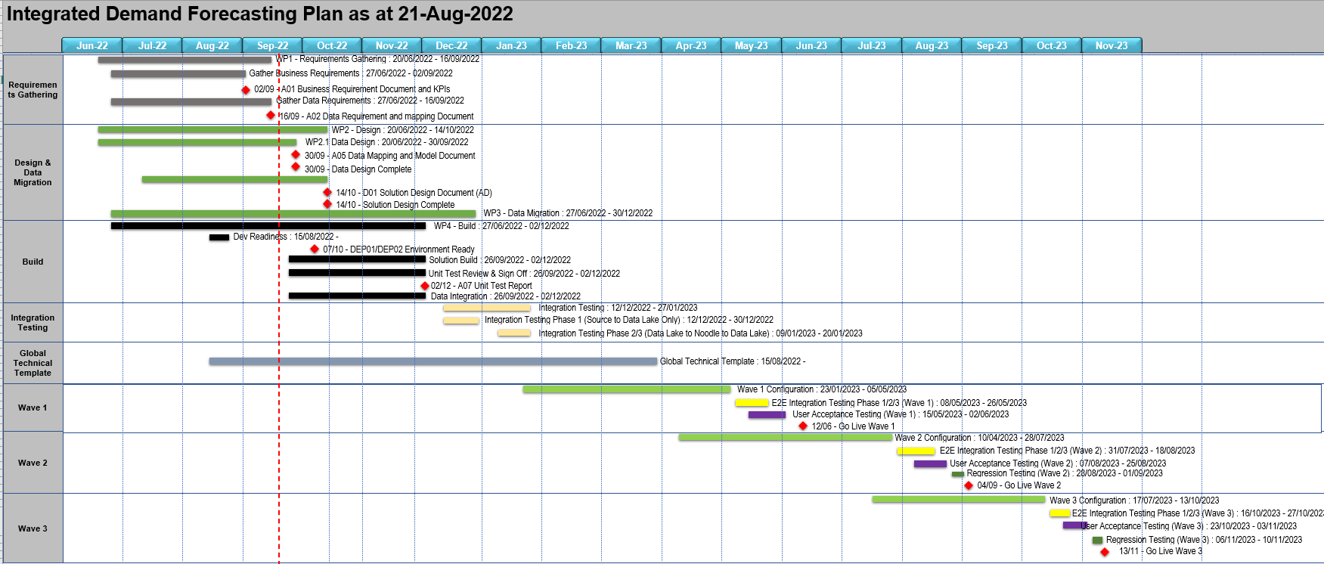

PROJECT TEST RESOURCE MODEL

Resource Plan
<A High-level indication of the number of test resources expected during the course of the project>

TO BE DEFINED IN <<PHASE>> TEST PLAN?

Resource Plan Roles & Responsibilities
Role | Name/s | Responsibilities
IB Programme Test Manager | Heena Patel
Data Hub Test Manager | Rohit Ravindran | Ownership of Data Hub testing, reporting directly to the Data Hub Project Manager.  Owns the facilitation & completion of the test scope  and management of the functional test team during System Unit Test Phase  Management of testing governance process including facilitation of test phase entry/exit criteria meetings  Script review against standards (approximately 10% of scripts)  Production and issue of test exit reports (System Unit Test Completion report.
Noodle Test Manager | ??
Project Test Assurance |  | To provide a periodic project specific objective assessment of the <test phase> stages; reporting risks, issues & associated mitigations and action plans to project management and senior stakeholders.  To support the <test phase> Lead in the build of the <test phase> approach in readiness for <customer> approval and the revision of the estimates and plan to deliver the <test phase> build and execute phase for the approved scope.  To support the <test phase> Lead to ensure the delivery to plan, validate the assessment of script quality and production of project reporting.
Defect manager |  | Management of the defect process for the project across all defined test phases including resolution & trend analysis following the guidelines defined in the Test approach document.
<Test Phase> Scoping Consultants |  | Assessment and confirmation of the prioritised <test phase> scope (test scenarios) for each of the <x> identified functional areas in scope <insert functional areas> including the preparation and facilitation of the Risk-based <test phase> workshops and the documentation of the prioritised scope per area.
<SI> Functional Experts |  | Provide initial process Q&A ad-hoc support and guidance for the solution to be implemented per area.  Attend the <test phase> scope workshops for each area and Integration workshops as required in the Scope schedule.  Review and approve the prioritised <test phase> scope for each functional area in readiness for <test phase> build & execution to commence to schedule.  To be available for any queries providing ad-hoc support and guidance for the solution to be implemented in their area, including data & process queries.  During the test execution phase attend defect management meetings to assess the criticality and priority of defects.
<Customer> Process Leads/Experts |  | Provide initial process Q&A ad-hoc support and guidance for the solution to be implemented per area.  Attend the <test phase> scope workshops for each area and Integration workshops as required in the Scope schedule.  Review and approve the prioritised <test phase> scope for each functional area in readiness for <test phase> build & execute to commence to schedule.  To be available for any queries providing ad-hoc support and guidance for the solution to be implemented in their area, including data & process queries.  During the test execution phase attend defect management meetings to assess the criticality and priority of defects
<Test phase> consultants |  | To develop test scripts related to their specific work stream, ensuring they are built to the correct standard, contain data and ensure they are signed off for execution.  To execute the tests related to their specific work stream and ensure any required defects are created, assessed and prioritised for completion. They will also ensure that tests are re-executed following the defect resolution.  To also provide support to the <customer> team and ensure they are delivering their scripts to plan.
Qualitest <Test phase> Analysts |  | To develop test scripts related to their specific work stream, ensuring they are built to the correct standard, contain data and ensure they are signed off for execution.  To execute the tests related to their specific work stream and ensure any required defects are created, assessed and prioritised for completion. They will also ensure that tests are re-executed following the defect resolution.
Customer < Test phase> Analysts |  | Attend the 1 day for scripting training & standards course as delivered by the Qualitest <test phase> Lead.  Completion of detailed scope review & assessment to support <test phase> Build and Execute commencing to schedule.  To develop test scripts related to their specific work stream, ensuring they are built to the correct standard, contain data and ensure they are signed off for execution.  To execute the tests related to their specific work stream and ensure any required defects are created, assessed and prioritised for completion. They will also ensure that tests are re-executed following the defect resolution.
Data manager |  | Overall responsible for the gathering of data requirements during the scripting phase and the coordination of the creation of data prior to <test phase> starting.
Other

Staff Training Needs
<A list of any specific training requirements in order to deliver the testing as planned i.e. the need to train internal client resources in the use of testing toolsets etc>

- Capgemini Development and Testing team will need training on the existing IB Demand Forecasting and Planning landscape, terminologies (e.g. APO Market, New Market, MSU, IYA, BOP, etc.) and high-level processes.
- Internal training sessions will be needed for testing team to understand the mapping between KPI’s and underlying raw data (RSKU/SSKU, sales and forecast data)

RAID

This section will be used to highlight the main Risks, Assumptions, Issues and Dependencies that were known at the time of writing this document.

Project Test Risks
<Details of any risks known, together with their impact on testing and overall plan for mitigation>

Certain risks are associated with any project and plans to mitigate these risks should be identified as early in the project as possible.

Risk | Impact on Testing | Mitigation Plans | Impact  (1-10) | Probability  (1-10)
- Complete list of data sources is not yet available and hence the Solution Design is not finalized | Potential Delays in Test Preparation and Test Execution Timelines | Data Analyst Team is working with Lesia and Hasan on identifying and validating the data sources | 8 | 8
- Lack of understanding of Power BI Data Model | The aggregate figures showing up on the dashboards cannot be validated if this understanding is not in place. | Organize cross training involving Data Analyst, Solution Architect development and testing teams to develop understanding. | 8 | 8
- Non-functional requirements are not yet confirmed by IB | NFR’s will not be taken into consideration during development and testing. | Follow-up with IB Business owners for this information | 7 | 8

Project Test Assumptions
<Details of any assumptions made when writing this document or when considering testing in general>

Certain assumptions are associated with any project, estimates, planning and dependencies.

Assumption | Impact on Testing | Review
- IB to perform Clean-up of Obsolete RSKU’s at a defined frequency | Will impact Data Quality and test results if not done.
- IB to ensure that there is no redundant data in APO across weekly and monthly forecasts | Redundant data will impact End-To-End Test Results in APO
- Noodle team to provide Forecast data mock files during Unit Testing phase for processing and Testing in Data Hub | Part of the flow where incoming Forecast data from Noodle is saved in and disaggregated in Data Hub cannot be tested if this data is not available.
- Sample of generated files (sales history, demand drivers, market size) to be shared with Noodle team for static verification. Noodle team to confirm that it is fit for consumption. | Not verifying this early will lead to issues in Integration and such issues will surface during End-To-End Integration Tests
- Forecast changes to be locked in APO by planners | Manual adjustments done by Demand Planner in APO will be overridden by New Weekly forecasts coming from Noodle.AI and result in confusion during End-To-End Testing
- Source Data will be extracted and made available in landing zone | Will block Unit or System Unit Tests

Project Test Issues
<Details of any known issues, their associated impact and activities planned/taken to resolve issues>

Certain issues are associated with any project and plans to address these issues should be identified as early in the project as possible.
Issue | Impact on Testing | Review

Project Test Dependencies
<Details of any known dependencies, their associated impact and activities planned/taken to resolve issues>
Certain issues are associated with any project and plans to address these issues should be identified as early in the project as possible.

Dependencies | Impact on Testing | Review
1. Points of Contact from APO ,Noodle.AI and Demand Planning team to be made available for support in below test areas:  - Initiating APO Forecast Changes from APO/BW that will be subsequently saved in Data Hub  - Provide Mock Noodle.AI Forecast into Data Hub  - Making changes to PSKU Mapping if such data is missing | Not following Data Feeds with correct cadence will result in inconsistent data sets being consumed by Consuming systems and Reports.
2. All conversion factors, PSKU Mapping, Product Groups, Unit of Measure and Geography must be accessible as CSV flat file and fed into Data Hub Test Environment | Inconsistent Master/Reference data will cause anomalies and impact test results

APPENDIX

N/A

